

1. **CREATE YOUR PROFILE:**
   1. Go to [www.imleagues.com/MWRRota/Registration](http://www.imleagues.com/MWRRota/Registration)

OR scan this QRcode:



* 1. Enter your information
  2. You will be sent an activation email, **click the link in the email to login and activate your IMLeagues account.**
  3. You should be automatically joined to your network

1. **SIGN UP FOR AN INTRAMURAL SPORT:**
2. Log in to your **IMLeagues.com** account.
3. Click on the “MWRRota” link at the top to go to your program’s homepage on IMLeagues.
4. The current sports will be displayed, click on the sport you wish to join.

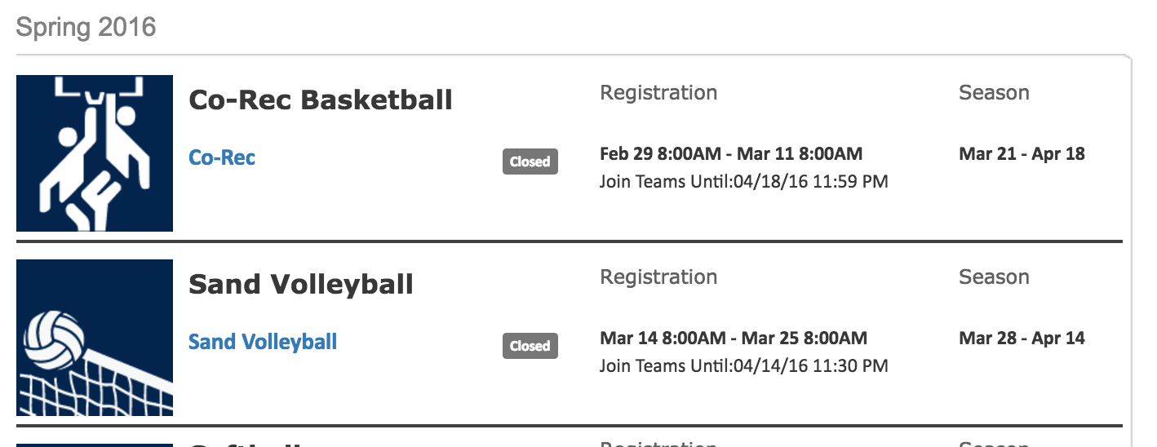

-Choose the league you wish to play in, and if applicable, choose the division you’d like to play.

1. You can join the sport one of three ways:

**i)**

* + **Create a team (For team captains)**
    1. Captains can invite members to their team by clicking “Team Options” and then “Invite Members” link on the team page. Any invited members must accept the invitation to be joined to your team.
       1. If they’ve already registered on IMLeagues: search for their name, and invite them.
       2. If they haven’t yet registered on IMLeagues: scroll down to the “Invite by Email Address” box, and input their email address.
  + **Join a team**
    1. Find existing teams on the league page and click the “join team” button to send a request to join a team.
    2. Accepting a request from the captain to join his team
    3. Finding the team and captain name on division/league page and requesting to join.
    4. Going to the captain’s playercard page, viewing his team, and requesting to join.
  + **Join as a Free Agent** 
    1. You can list yourself as a free agent in as many divisions within a league as you’d like. You will be visible to all members of the site and can request to join teams, or post information about yourself so teams can request to add you to their team.